FOR SALE
‘Rocketeer’ Moody 31 Mark II Fin Keel 1988. £ 26000 inc VAT, offers considered/ negotiable.
Moored at Cowes Corinthian Yacht Club, Cowes,Isle of Wight, England.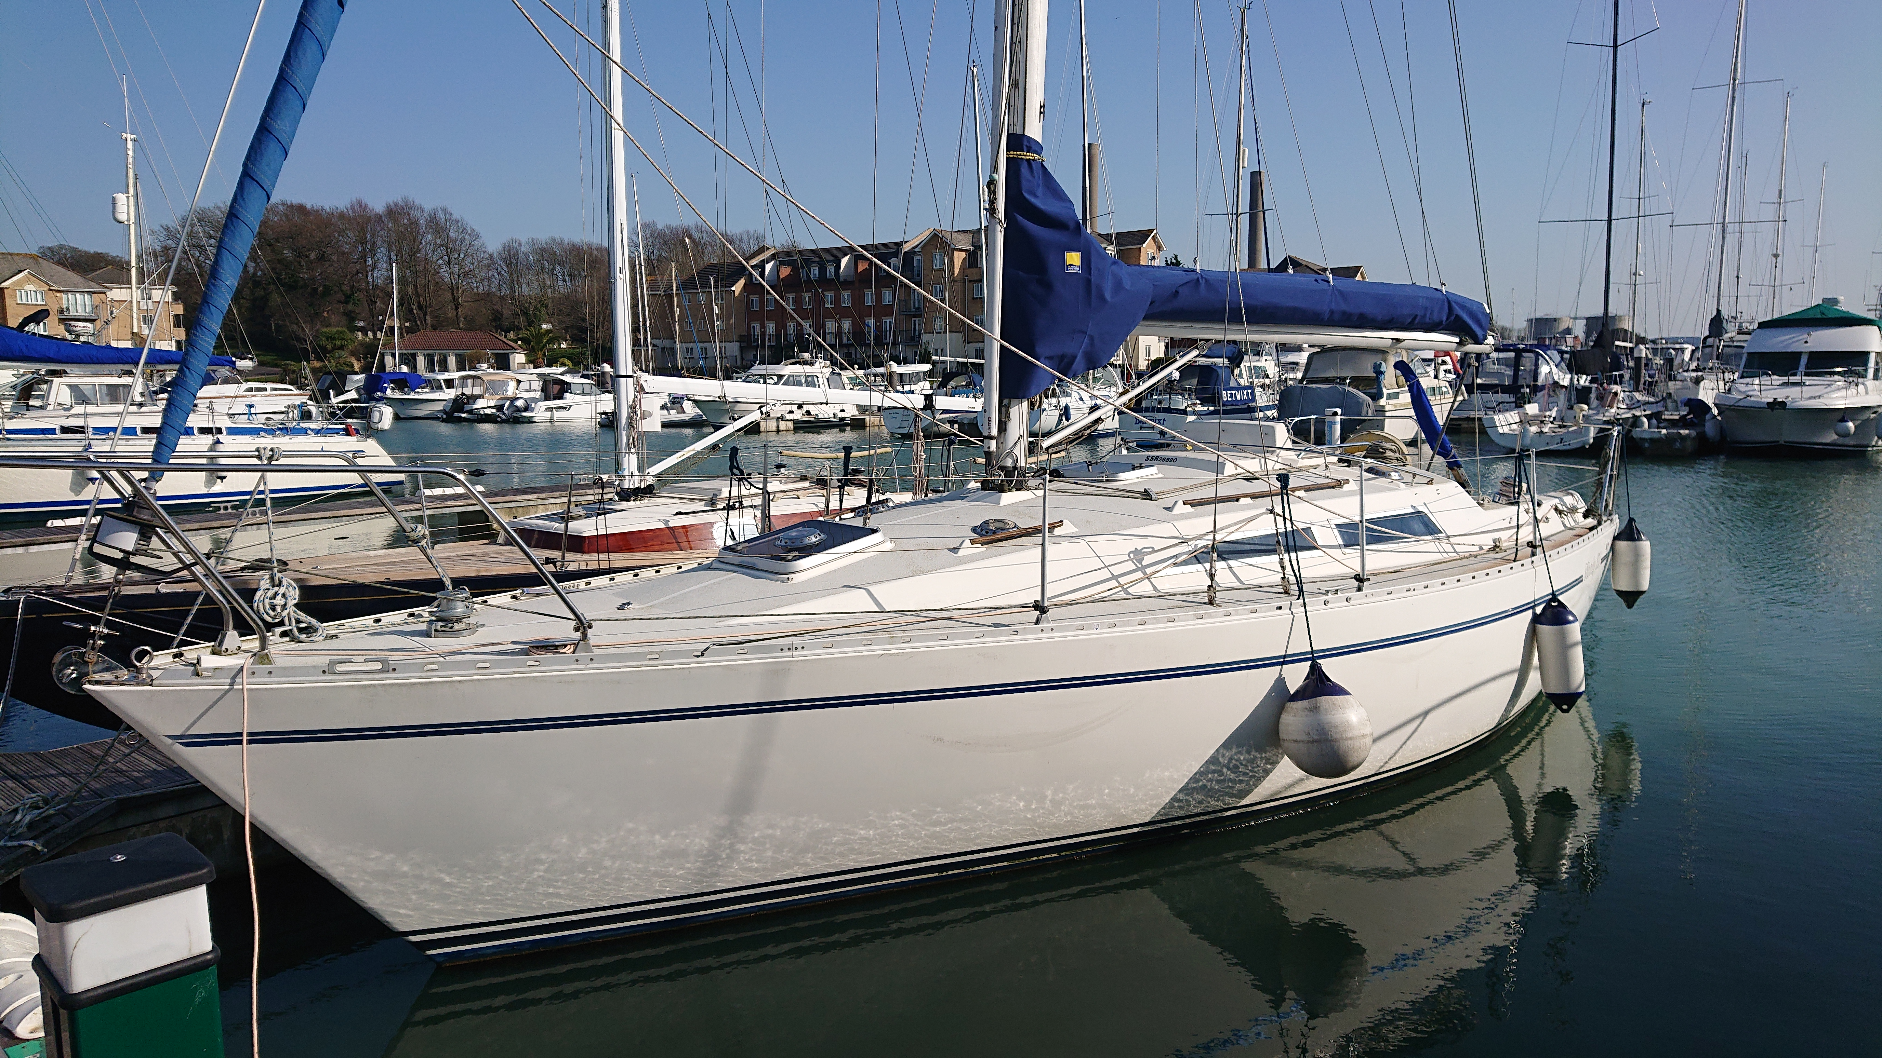

Rocketeer has been well maintained and looked after. Current ownership is since 2015 with many updates,replacements and additions. She has been lightly sailed in the Solent area locally. Sold VAT paid and without any financial encumbrances. 6 berth. White GRP hull and superstructure. Kemp/Selden mast and spars.Saloon with dropleaf table,upholstered bench seats.
Running rigging has been regularly inspected and replaced as necessary, standing rigging has been regularly inspected and in good condition. Winches: 2x Lewmar ST40 self tail 2 speed, 2x Lewmar 30 two speed, 1single 8 and 1single 6 mast winches.
Engine Volvo Penta 2003 28hp r/w cooled . Shaft drive. New cutless bearing and shaft seal. Shaft rope cutter. Rebuilt coolant pump. Tiller steering.
Lines from mast including slab reefing running back to cockpit.
Furlex furling gear for genoa with lines running aft
Hatch covers and roof lights in main cabin recently reglazed
Shore power with 3 sockets plus battery charger.
Hull regularly inspected and anti fouled. No osmosis. Keel studs/fixings in good condition/rust free. All seacocks replaced with GR Trudesign fittings. Jabsco heads/toilet. 2x sinks with manual footpumps
Full detailed maintenance log available, Viewing,inspection and survey by arrangement. Boat is ready to sail.
Contact: Henry Williams 07747796807 littlerevelend@hotmail.com
Inventory:
Garmin GPS152 trackplotter,
ICOM fixed vhf M323G c/w built in GPS, Handheld vhf Standard Horizon HX270E,
Autohelm ST50(wind direction etc),
NASA Clipper depth/echo sounder
Raymarine Autohelm ST2000/tiller pilot .
Stowe Navigator(distance/speed).
Firdell radar mast blipper

Compass on cockpit bulkhead. Master Sterling Volt mains/ battery charger, two Numax 12v batteries(recently replaced). Shore power connections. All lights replaced with LEDs. 12v Fridge. Voyager calor cooker new 2015, rarely used/as new ,two hobs, grill and oven. Manual anchor windlass,chain,CQR anchor. Full galley inventory.
Seago 4 person life raft 2022. Horseshoe buoy/light. Danbuoy marker. Lifejackets, webbing jackstays, Rescue flares, Various other safety equipment, warps and lines
Sails:
Main(in lazyjacks/sailbag new 2022) Lucas sails 18sq mt, 2004. Good condition dacron, regularly maintained. : IYE sheet traveller with end cleats, 3-1 ratio.
Furling genoa 34 sq mt. UV strip, on Furlex furler, Lucas sails 2003 . Good condition dacron, regularly maintained. Telescopic Spinnaker pole. Rod kicker. Fenders, Boat hook. Sail sheet bags,
Optional additions: Asym cruising chute/genneker 60 sq mt Crusader sails 2020- Tri-radial m/f 0.9 u.s oz ripstop nylon, with snuffer (squeezer) - as new
Inflatable Dinghy.

Cabin/cockpit: Eberspacher cabin heater. Auto bilge pump(also hand Urchin bilge pump). New Jabsco heads disch. hose. Racor secondary diesel filter fitted.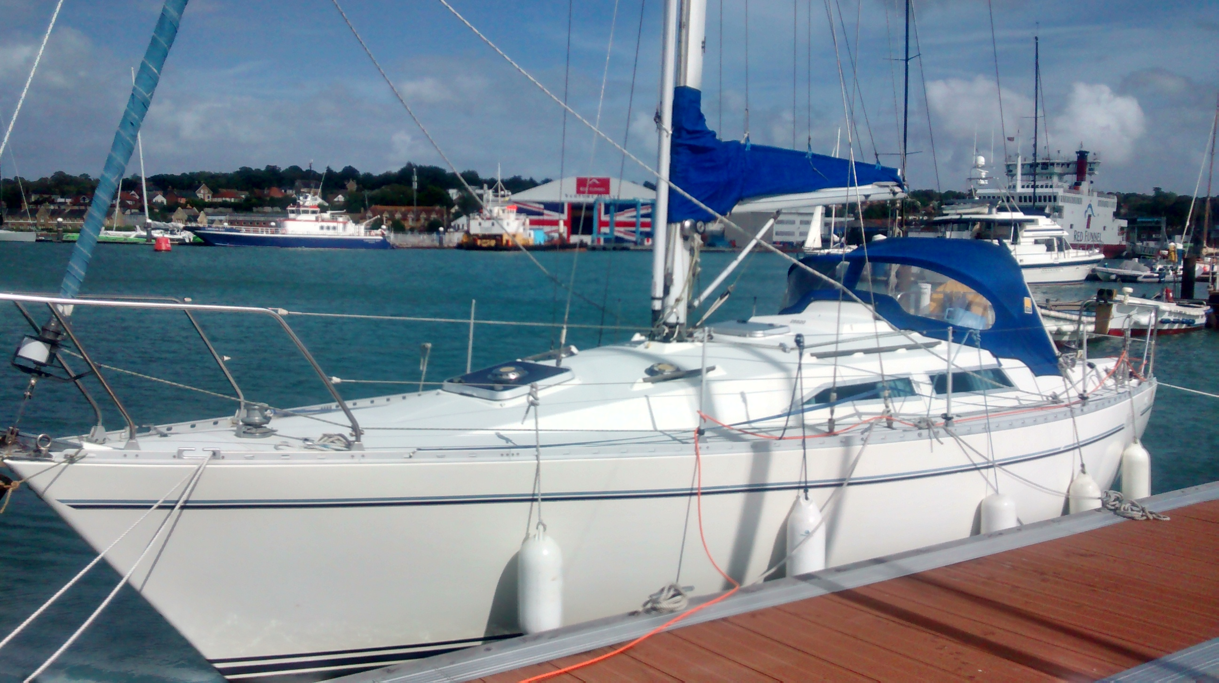

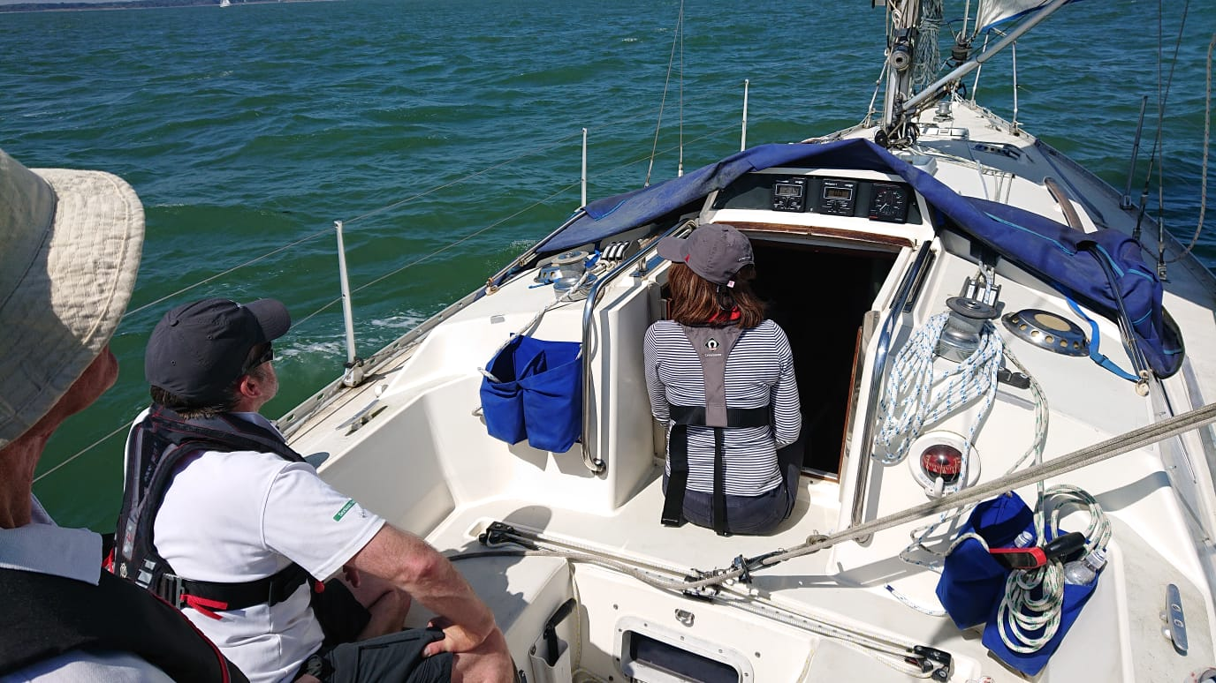

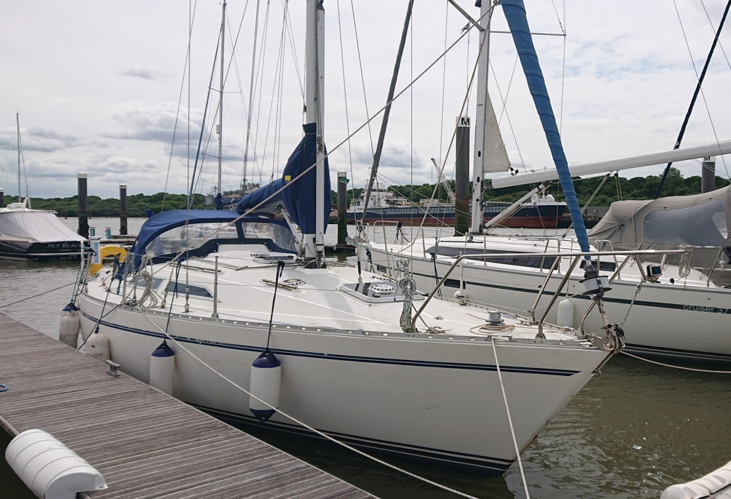

Can be inspected and seen on the E.Cowes marina pontoon. Serious buyers may be offered an accompanied test sail. Haul outs and surveys at buyers cost, unless otherwise agreed.

